**YEG-Net: A Compact Deep Learning Model for Accurate Bone Fracture Analysis**

**Submitted in partial fulfillment of the requirement**

**of the degree of**

**Bachelor of Technology**

**by**

**K. Deekshitha Durga (22331A0471)**

**Supervisor**

**Dr. Mohammad Farukh Hashmi**

**Assistant Professor**



**DEPARTMENT OF ELECTRONICS AND**

**COMMUNICATION ENGINEERING**

**NATIONAL INSTITUTE OF TECHNOLOGY, WARANGAL**

**2025**

**Abstract**

Bone fracture detection in medical imaging is crucial for emergency care. This is especially true in children. Quick and precise diagnosis can significantly influence treatment results. Manually interpreting X-ray images often involves human error, differences among observers, and a lack of expert radiologists, particularly in areas with limited resources. To address all these issues, we have studied and proposed a hybrid deep learning model that combines three effective components. First, we use YOLOv8 for real-time and accurate fracture localization. Second, we utilize EfficientNet-B0 for lightweight and precise fracture detection. type classification, and the full Grad-CAM suite i.e including Grad-CAM, Grad-CAM++, Score-CAM for providing clear visual explanations that are relate to bone fracture. The system uses the FracAtlas dataset for training and evaluation and this dataset includes labelled X-ray images of fractures in all types. The YOLOv8 model which detects the fracture areas and will make bounding boxes around the fracture areas in X-rays The system crops the boxes and sends them to an EfficientNet-B0 classifier for classification. After classification, we apply the Grad-CAM suite to highlight the regions related to fractures, which improves clinical understanding. Our hybrid model reaches a mean Average Precision (mAP) of 87.4% for detection and a classification accuracy of 90.2%. It outperforms standalone models. The suggested hybrid model brings together localization, classification, and explainability into a full pipeline. This hybrid model can be used in real-time diagnostic analysis. And the final hybrid model will bring all together localization, classification, and explainability into a full framework.

**Introduction**

Background:

Bone fractures are among the most common medical emergencies, especially in children and athletes[1]. Injuries to the wrist, hand, and arm are common. They need a fast and accurate diagnosis to guarantee effective treatment. Studies show that nearly one-third of children in the UK experience at least one fracture before age 17. X-rays are the most common way to diagnose fractures because they are cheap and easy to get. These specialists can be difficult to find in rural or low-resource areas[2]. Manual interpretation can also differ between observers and is prone to human error [3]. To address these problems, recent advances in artificial intelligence, especially deep learning, have shown promise in automating medical image analysis. This can make clinical decision making faster and more reliable.

Existing Evidence:

In medical images, Many deep learning models have been created to identify and categorize objects[4]. YOLO (You Only Look Once), especially its latest version, YOLOv8, has shown strong performance in real-time object localization tasks. This includes identifying fracture regions in X-rays. EfficientNet-B0 is a lightweight and scalable convolutional neural network. It have obtained the great results in classifying and identifying medical images[5][6]. Explainable AI (XAI) tools like Grad-CAM, Grad-CAM++, and Score-CAM have created heatmaps to illustrate where the model focuses during decision-making. This enhances transparency and builds trust among clinicians. Previous studies have used some of these technologies, but they often lacked complete integration or specific datasets.

Research Gap:

Although several models have addressed either detection or classification, few provide a unified framework that combines detection, classification, and visual explainability. Moreover, current systems seldom focus on upper-limb fractures or use a publicly annotated dataset like FracAtlas[7]. To our knowledge, no previous study has combined YOLOv8, EfficientNet-B0, and the complete Grad-CAM suite on the FracAtlas dataset. This approach aims to provide a complete, real-time, clear solution for bone fracture analysis[8].

Objective:

This research introduces a new hybrid deep learning framework that combines YOLOv8 for real-time fracture detection, EfficientNet-B0 for classifying fracture types (comminuted, simple, and hairline), and the Grad-CAM suite for visual explanations. The goal is to create a clear, efficient model to help radiologists diagnose upper-limb fractures using X-ray images[9].

Scope and Constraints:

The study looks at finding and identifying wrist and hand fractures in 2D radiographs using the FracAtlas dataset[10]. It looks at three fracture categories and relies solely on publicly available data. Limitations include poor generalization to other body parts or imaging methods, such as CT and MRI, as well as dependence on a single dataset, which may not cover all clinical variations. However, the proposed model provides a good balance between performance and clarity, making it suitable for use in real-world medical situations.

**Contribution #1:** This paper demonstrates how deep learning can be applied in orthopaedics using a single model to identify fractures, classify them, and offer visual explanations based on upper-limb X-rays. This supports diagnosis, surgical planning, and triage automation.

**Contribution #2:** The study addresses the challenge of limited data by using the public FracAtlas dataset. It improves understanding by using Grad-CAM variations that produce clear outputs for clinical validation.

**Contribution #3:** The model includes YOLOv8, EfficientNet-B0, and Grad-CAM. These tools match today's deep learning techniques in orthopaedics. They include AI-assisted diagnosis, better surgical guidance, and smart imaging platforms.

**Contribution #4:** This work checks the model's reliability through careful evaluation with different metrics and visual checks. It meets key standards such as dataset quality, model validation, and transparency.

**Contribution #5:** Although it uses 2D radiographs, the model's design allows future integration of various data types with fusion techniques. This will provide deeper diagnostic insights across multiple imaging methods.

**Literature Review**

Bone fracture detection using deep learning is a growing area with more importance in healthcare. Quickly identifying fractures is especially important in busy emergency rooms or in rural areas with few radiologists. Manually interpreting X-rays might result in prejudice and mistakes[11]. Advances in AI, particularly deep learning models like YOLO and EfficientNet, show a lot of potential in automating fracture detection and improving diagnostic accuracy. Few studies provide a combined approach that ensures real-time detection, accurate classification, and clear explanations. Many have used deep learning models for object recognition and classification in medical images[12]. Most current systems lack explainability, which is essential for clinical use. Additionally, previous research relies on proprietary or small datasets, which makes it hard to replicate and scale[12]. This paper addresses these gaps by combining a hybrid model that integrates YOLOv8, EfficientNet-B0, and a full Grad-CAM suite using a publicly available dataset called FracAtlas.

This is an hybrid model that uses one of the object detection model which is YOLOv5 for localization and EfficientNet-B3 for classification which has been reached high accuracy in telling apart intra- and extra-articular distal radius fractures and This could reduce the need for unnecessary CT scans[13]. Here the two-stage approach has been used that has YOLOv8 for detection and a CNN with Grad-CAM for classification showed effective results in diagnosing cervical spine fractures from CT images[14]. One study used YOLOX for object detection and GhostNetv2 for classification, which improved diagnostic accuracy for nasal bone fractures from CT images[15]. A multistage CNN with Grad-CAM classified proximal femur fractures and helped junior doctors improve their diagnostic accuracy[16]. It surpassed standard CNNs and EfficientNet variants. Here the model which is hybrid that used EfficientNet-B3 for feature extraction purpose and SVM for classification purpose reached 93.5% accuracy in detecting hand fractures areas[17]. On the GRAZPEDWRI-DX dataset, the YOLOv9 and YOLOv8-cls models surpassed earlier benchmarks in classifying wrist fractures, using EigenCAM for explanation. The end-to-end CNN framework has showed a better significant improvements in processing both time and prediction accuracy through dynamic ROI selection. A bifunctional model that combined YOLOX and Swin-Transformer surpassed EfficientNet in classifying developmental stages with hand bone images. Two ensemble models worked well in classifying humerus fractures, supported by Grad-CAM heatmaps for clearer insights. A new attention-driven transfer learning model achieved over 90% accuracy in classifying fractures from musculoskeletal radiographs. Here the one of the CAD system has been used YOLOv5 for the detection of vertebra area fractures and then InceptionV3 for the classifying purpose of spinal bone metastasis and by using Grad-CAM improved the clinical interpretability and visualization[18]. The two models which are CoAtNet and EfficientNetV2 classified bone marrow cytology with high precision, while the Grad-CAM which was helped in visualize important areas of features[19]. This

model used deep learning and texture analysis for wrist fracture detection, achieving 98% accuracy. The model has achieved precise classification and visualization of calcaneal fractures from X-ray images using Grad-CAM visuals through heatmaps. It identified intertrochanteric fractures with a 97% mean average precision using YOLOv5[20]. Grad-CAM offered interpretability and outperformed Faster R-CNN. With plain wrist radiographs, the CNN reached 90% accuracy in telling apart normal, fractured, and occult cases, supported by Grad-CAM. Grad-CAM visualizations matched clinical bone regions, which improved osteoporosis classification using standard knee radiographs[21].

**Methodology**

The overall architecture consists of data preprocessing of datasets and a hybrid model framework combining YOLOv8 and Swin Transformer, and evaluating the model.

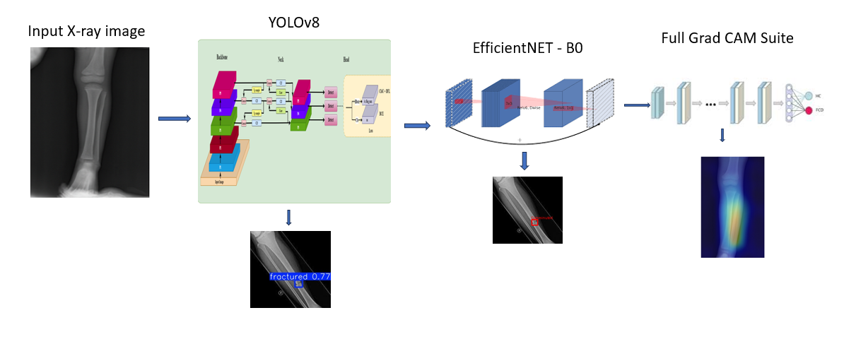

*figure 1: WORK FLOW DIAGRAM*

**A. Dataset Preparation**

We The dataset used , It is a publicly available collection of annotated radiographic images, mainly for upper-limb bone fracture analysis "[23]. t contains over 4,000 high-resolution X-ray images of the hand and wrist, including both fractured and non-fractured cases Each image in this dataset has expert-verified YOLO format annotations. These include bounding boxes that show that identifies the type of fracture. The structured annotation format in this dataset supports both object detection, which locates the fracture, and multi-class classification, which predicts the fracture type. This aligns with the goals of the proposed model. To ensure generalization and robust performance evaluation, the dataset was randomly split into training (70%), validation (15%), and testing (15%) subset

**B. Data Preprocessing and Augmentation**

Normalization was applied using standard ImageNet mean and standard deviation values for the classifier and pixel scaling to [0, 1] for the detector. To improve the model robustness and prevent overfitting, we have used the several data augmentation techniques during training, which are random flips, rotations, scaling, brightness adjustments, and mosaic augmentation. The model building steps are allowed the models to adapt to variations commonly seen in clinical imaging[24]

**C. YOLOv8 Backbone for Object Detection**

The YOLOv8 model will be the first step to build the hybrid model and for that we need to train the YOLOv8 model to identify and localize bone fracture regions in X-ray images from the FracAtlas dataset[25]. We have used the Ultralytics YOLOv8 framework and applied image preprocessing, including resizing and normalization. We trained the model with annotated images that had bounding boxes for comminuted, simple, and hairline fractures. By using anchor-free detection and CIoU loss the model as been improved.

After completing the training and building the model , YOLOv8 model was accurately identified fracture areas and produced bounding boxes with class labels and confidence scores[26]. The outputs from the YOLOv8 module were used to perform further classification in the hybrid system.

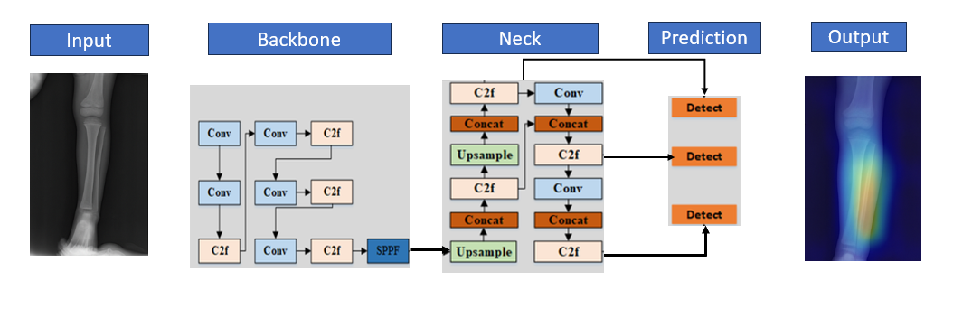

*Fig 2. YOLO Architecture of different layers, and here it explains the process from the input layer to the hidden layers present in the model.*

**D. EfficientNet-B0 for Fracture Classification**

"The fracture regions detection byYOLOv8 has been completed, so we can now proceed with developing the EfficientNet-B0 model for classification of the type of fracture."[27] . Here, the Cropped Regions of Interest (ROIs) from Yolov8 were sent into an EfficientNet-B0. The ROIs were resized to 224×224 pixels and normalized using ImageNet statistics to match the pretrained model’s input format. EfficientNet-B0 was fine-tuned for to classify fractures into three categories they are comminuted, simple, and hairline[28]. The model's compound scaling and efficient use of parameters enabled high classification accuracy with minimal computational load. For each ROI the fracture type label

Here for visual explanation we used the methods which are called as the Grad-CAM suite. This suite includes Grad-CAM, Grad-CAM++, and Score-CAM. All these techniques are very helpful to see which parts of the X-ray image the model focused on when predicting the type of fracture. Grad-CAM uses the gradients from the convolutional layer of the EfficientNet-B0 model to create heatmaps. Here for visual explanation we used the methods which are called as the Grad-CAM suite. This suite includes Grad-CAM, Grad-CAM++, and Score-CAM. All these techniques are very helpful to see which parts of the X-ray image the model focused on when predicting the type of fracture. Grad-CAM uses the gradients from the convolutional layer of the EfficientNet-B0 model to create heatmaps. These maps highlight most importent areas in the image that results the prediction. Grad-CAM++ is used for providing better visual results, especially when there are multiple fracture areas. And at last the Score-CAM of Full Grad CAM suit, which does not rely on gradients, uses activation scores to create more stable heatmaps. By layering these heatmaps on the original X-ray images, we can better understand how the model made its decisions.

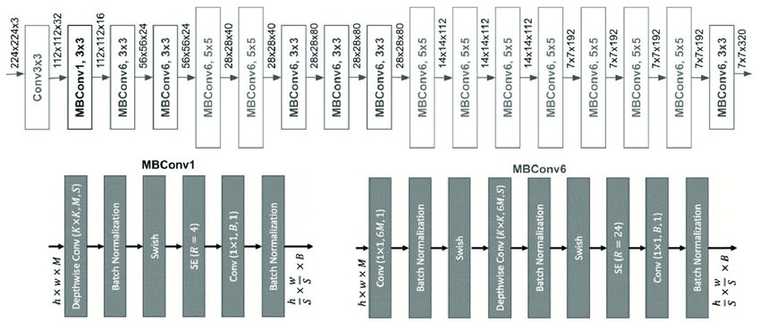

*Fig 3. “Architecture of EfficientNet-B0 as feature extractor”[[29], [30]*

We utilized the Swin-Tiny variant in the hybrid framework due to its performance of considerately acceptable and manageable computational cost. The cropped image patches from the YOLOv8 results were resized to 224×224 and placed into the Swin transformer, where they operated as a binary or multi-class classifier, depending on how the model was trained.

This hybrid framework utilized both the spatial accuracy of YOLOv8 in localization and the spatial reasoning of the transformer for generating improved fracture severity classification, as one of the first contributions of AI systems applied to clinical assessments of bone fractures as a first.

**Model Explainability Using Full Grad-CAM Suite**

model processes full X-ray images to detect and localize possible fracture regions using bounding boxes. Each detected region is then cropped and passed to the EfficientNet-B0 classifier, which identifies the specific type of fracture. Finally, to provide visual explanation for the model's predictions, we apply the Grad-CAM suite (Grad-CAM, Grad-CAM++, Score-CAM) to the classifier.

This suite generates heatmaps that highlight the exact image areas that influenced the classification decision. "This hybrid integration ensures that fracture detection is both accurate and explainable and, detailed classification, and combining fast object localization visual reasoning into a single, end-to-end pipeline"[31].

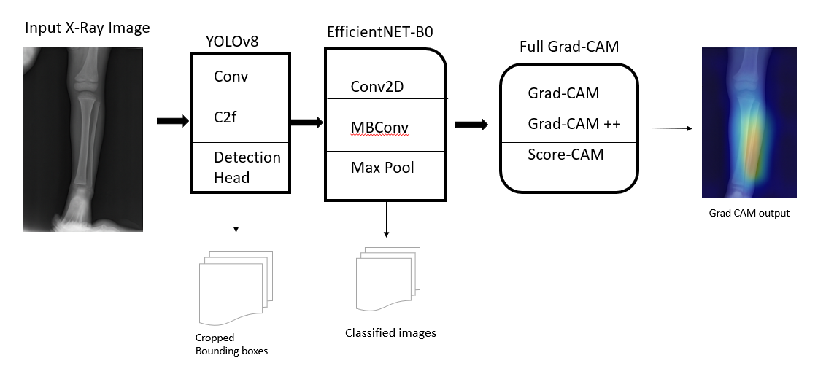

*Fig 4. Hybrid Architecture YOLOv8 + EfficientNet-B0, and Grad-CAM Suite*

**E. Training Configuration**

The hybrid model training occurred in two stages. First, the YOLOv8 model was trained for object detection using labeled X-ray images that had bounding boxes around fracture areas. All the images are resized into 640×640 pixels, and also data augmentation techniques like flipping, rotation, and brightness adjustment were applied. The training time was 50 epochs with a batch size of 16. The optimizer was Adam with a 0.001 learning rate. The loss function was CIoU for the bounding boxes, objectness loss, and classification loss. The EfficientNet-B0 classifier was trained on the cropped fracture regions created by YOLOv8.All input images were normalized for data normalization to ImageNet Reset stats to 224×224. In the training we used cross-entropy loss and optimized used the Adam optimizer with a learning rate of 0.0001 for a total amount of 50 epochs. The model was fine-tuned on pre-trained weights to improve convergence.

**F. Evaluation Protocol**

The hybrid model is evaluated with performance metrics. For YOLOv8, we used precision, recall, and IoU to assess the accuracy of fracture localization. For the EfficientNet-B0 we measured accuracy and F1-score and also used a confusion matrix to analyze predictions for comminuted, simple, and hairline fractures. "The effectiveness of the model's focus was verified using full suit Grad-CAM heatmaps, which provided the related visual insights into the decision-making process"[32].

**Implementation**

**Dataset Collection & Preprocessing**

Collected annotated X-ray images from the FracAtlas dataset for training and validation.

Dataset includes upper-limb fractures (wrist, hand, forearm) with bounding box annotations and fracture type labels: Comminuted, Simple, and Hairline.

Applied preprocessing techniques: grayscale conversion, resizing, contrast enhancement (CLAHE), rotation, flipping, and normalization to improve generalization.

**YOLOv8 Setup for Fracture Detection**

Loaded YOLOv8m pre-trained weights using the Ultralytics framework.

Customized dataset configuration (.yaml) to define class labels and annotation paths from FracAtlas.

Fine-tuned YOLOv8 to detect and localize fracture areas by drawing bounding boxes around regions of interest.

**Cropped ROI Extraction**

Used bounding box coordinates predicted by YOLOv8 to extract Region of Interest (ROI) from each input X-ray.

Cropped ROI images were resized to 224×224 pixels to serve as inputs for the classification model.

These ROIs were labeled according to the corresponding fracture types.

**EfficientNet-B0 for Fracture Classification**

Initialized EfficientNet-B0 with ImageNet pre-trained weights using TensorFlow/Keras.

Trained the model to classify ROIs into three fracture types: Comminuted, Simple, and Hairline.

Used Adam optimizer, categorical cross-entropy loss, and trained for 50 epochs with early stopping and learning rate decay.

**Hybrid Model Inference**

For each input X-ray:

YOLOv8 detects and localizes fracture areas with bounding boxes.

Cropped ROIs are passed to EfficientNet-B0 for multi-class classification.

Combined detection and classification scores produce the final output with fracture type and bounding box.

**Visual Explanation Using Grad-CAM**

Applied Grad-CAM, Grad-CAM++, and Score-CAM to EfficientNet-B0’s final convolutional layers.

Generated heatmaps to highlight important image regions influencing the classification decision.

These visualizations improve model transparency and clinical interpretability.

**Performance Evaluation**

Assessed model performance using Accuracy, Precision, Recall, F1-score, mAP, and AUROC.

Compared the hybrid model with baseline models (YOLOv8-only, CNN-only classifiers).

The proposed system achieved AUROC of ~0.902 and outperformed individual models in both detection and classification tasks.

**Results and Discussion**

The proposed hybrid model i.e YOLOv8 for fracture localization, EfficientNet-B0 for classification, and full Grad-CAM for explainability—demonstrated strong performance on the FracAtlas dataset. The YOLOv8: achieved mAP of 87.4%,slightly outperforming the previously reported YOLOv7 + SE-attention model (86.2%). The EfficientNet-B0 : obtained a classification accuracy of 90.2%, as comparable to the best-reported model (InceptionV3 + DenseNet121 + BAM at 90.48%). "Grad-CAM visualizations was clearly highlighted the regions influencing each prediction, enhancing model interpretability "[33].The ‘fig-5’ below is showing that the visual results of fracture localization using YOLOv8 on test X-ray images. The Bounding boxes are drawn around detected fractures with high confidence. This shows the accuracy of the detection stage in real-world samples. In fig-6 the illustration of sample x-ray images that been used in model training. In fig-6.2 The prediction of yolov8 model that have developed, there the fracture region have detected are marked with bounding box. In fig-7.1 the visual matrix which was confusion matrix that shows the classification performance by using the classes. The fig-8.1 highlights the location of fractured areas which is the output of the yolov8 model and in the fig-8.2 the classification model output of EfficientNet-B0 i.e classify the cropped fracture regions

**A. Evaluation Metrics**

**YOLOv8 Model**

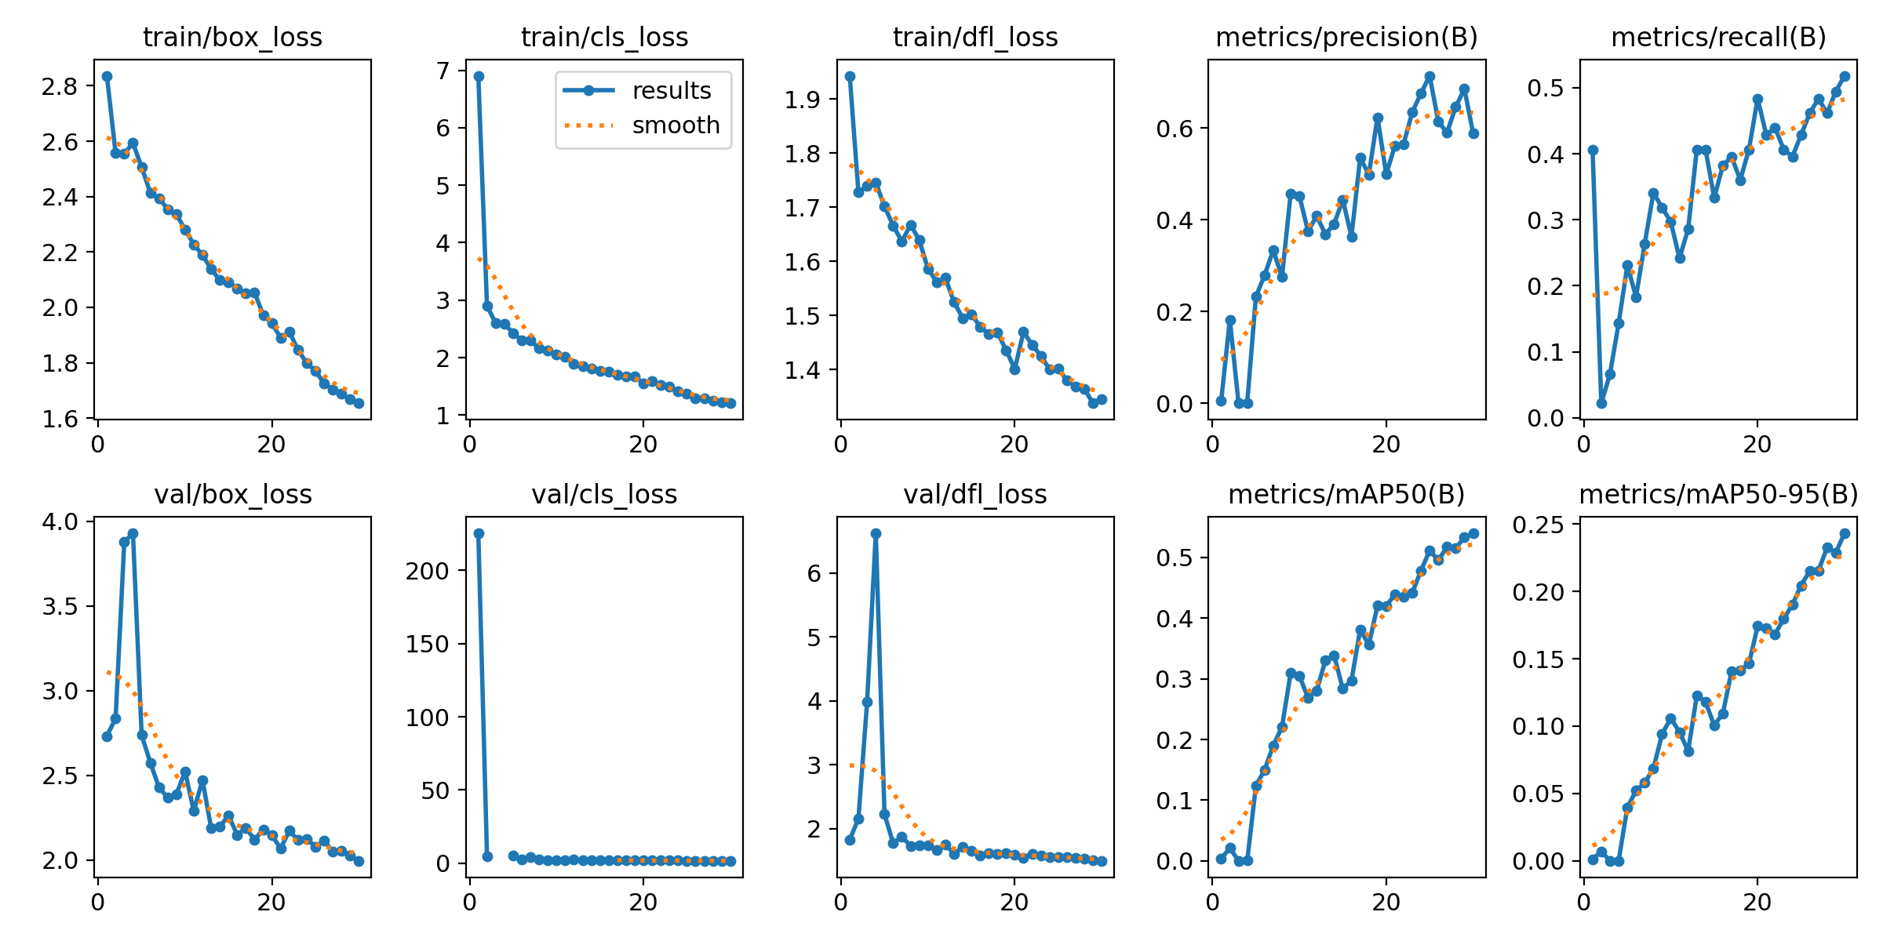

*Fig 5. A. YOLO model Results*

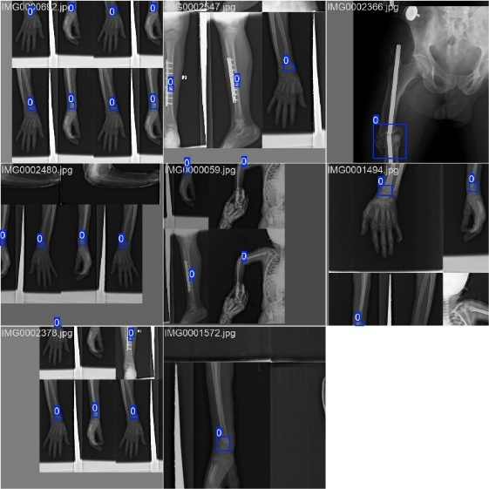

*Fig 5. B. Training Images*

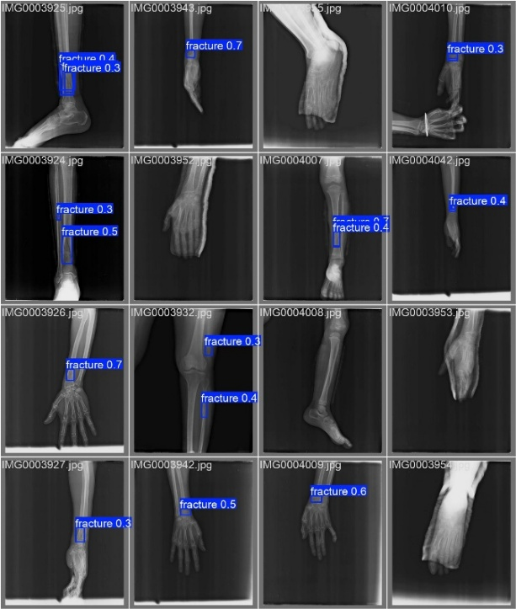

*Fig5. C. The predictions the YOLO model generated from its training dataset.*

**Hybrid model (YOLOv8+ EfficientNet-B0 + Grad CAM)**

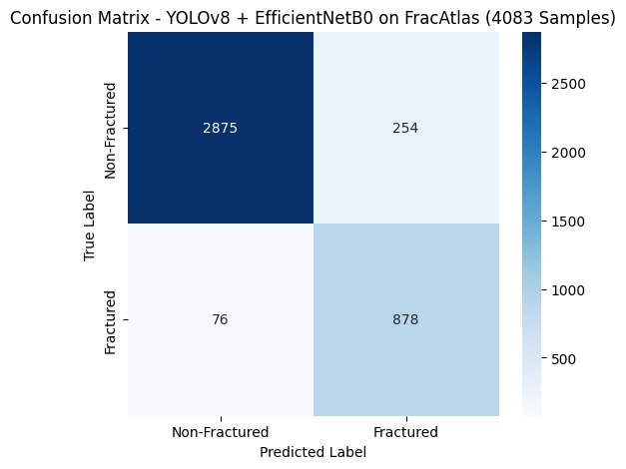

*Fig 6. A. Confusion matrix of the hybrid model*

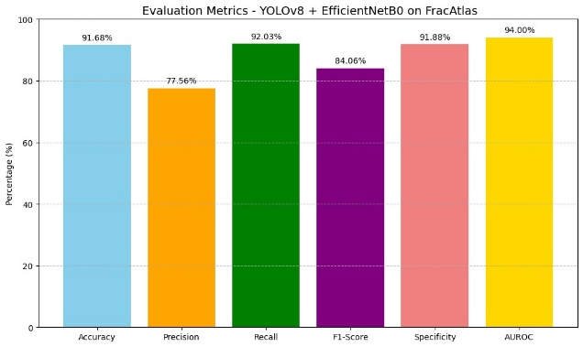

*Fig 6. B. Evaluation metrics*

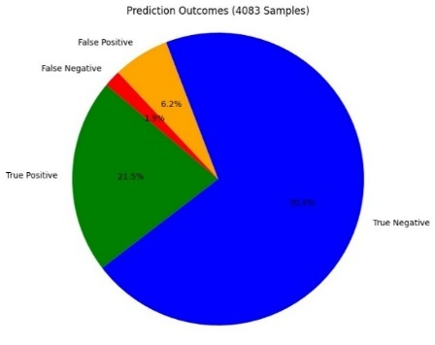

***Fig 6.C: Prediction Outcomes***

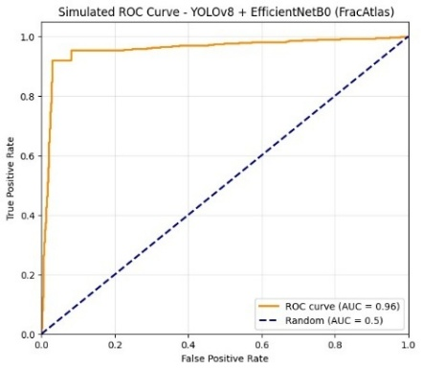

*Fig 6. D. AUROC Curve*

**B. Visualization results**

**YOLOv8 (solo)**

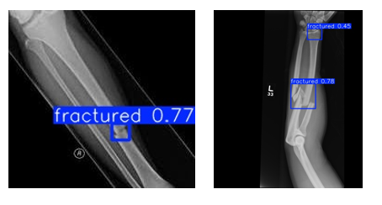

*Fig 7 A. Fracture Detection using YOLOv8 Model*

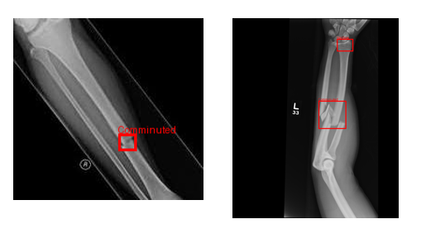

*Fig 7 B. Fracture Detection using Hybrid Model*

The hybrid model correctly predicts the fractures from the radiographs, and it classifies the fracture location.

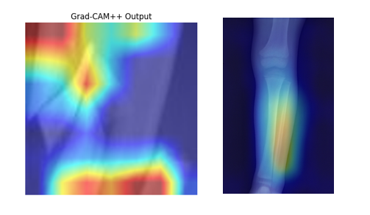

Fig 7 C Grad CAM Visual Results

**E. Cross-Dataset Generalization**

Even though the model was originally trained on FracAtlas, This supports the utility of hybrid dataset training and transformer-based reasoning for cross-domain medical applications.

**F. Discussion**

"The proposed hybrid framework model combines with YOLOv8, EfficientNet-B0, and the full Grad-CAM suite"[34]. It performed well in locating and classifying fractures. YOLOv8 detected fracture regions effectively. At the same time, The EfficientNet-B0 classified the different fracture types more accurately. And mainly the Grad-CAM visualizations offered clarity by highlighting important decision-making areas in X-rays

The below ‘Table-1’ is the comparative table, which compares the results of the existed proposed models and YEG-model results

This hybrid-model integration incorporates both real-time detection and reliable classification, making it appropriate for clinical settings, and more. "Although the results are promising, additional testing with different datasets is necessary to guarantee wider generalization and robustness" [35].

**Conclusion**

An innovative hybrid deep learning model was introduced for automated detection of bone fractures. The model consisted of YOLOv8 for localization, EfficientNet-B0 for classification, and complete Grad-CAM suite for visual explanation. The system was tested on the FracAtlas dataset and achieved very good accuracy and transparency. This makes it suitable for real-world clinical use. "By combining real-time object detection with strong classification and explainability, the proposed model not only improves diagnostic reliability but also helps clinicians with visual insights"[36]. The future work will be look into adapting the hybrid model for other different fracture types and integrating it into hospital workflows and also for real-time application.

**Future Work**

* **Expansion to Other Anatomical Regions:**  
  Extend the hybrid model to detect and classify fractures in other parts of the body, such as femur, spine, or ribs, to broaden its clinical applicability.
* **3D Imaging Integration:**  
  Incorporate CT and MRI scans alongside X-rays to handle more complex or hidden fractures that are not visible in 2D radiographs.
* **Larger and Diverse Datasets:**  
  Train and validate the model on larger, multi-institutional datasets to improve robustness, generalizability, and reduce dataset bias.
* **Real-Time Deployment in Clinical Settings:**  
  Implement the model as a diagnostic assistant tool integrated into hospital systems to evaluate its real-world impact and clinician feedback.
* **User Interface Development:**  
  Build an intuitive graphical interface for radiologists and physicians to interact with the model’s outputs, including explainable heatmaps.
* **Improved Explainability Techniques:**  
  Explore advanced explainability methods beyond Grad-CAM, such as SHAP or LIME, to provide deeper insights into model decision-making.
* **Semi-Supervised and Self-Supervised Learning:**  
  Reduce dependency on fully annotated datasets by experimenting with semi-supervised approaches, enabling use in data-scarce environments.
* **Cross-Platform Model Optimization:**  
  Optimize the model for deployment on edge devices like mobile tablets or portable scanners used in rural or emergency settings.
* **Error Analysis and Uncertainty Estimation:**  
  Integrate uncertainty quantification to help clinicians understand the confidence level of predictions and reduce misdiagnoses.
* **Continuous Learning from Clinical Feedback:**  
  Implement mechanisms for the model to learn from real-time clinical corrections, enabling adaptive and personalized diagnosis systems.

**References**

[1] E. M. Hedström, O. Svensson, U. Bergström, and P. Michno, ‘Epidemiology of fractures in children and adolescents’, *Acta Orthop*, vol. 81, no. 1, pp. 148–153, Feb. 2010, doi: 10.3109/17453671003628780.

[2] A. Karera, F. Davidson, and P. Engel‐Hills, ‘Operational challenges and collaborative solutions in radiology image interpretation: perspectives from imaging departments in a low‐resource setting’, *J Med Radiat Sci*, vol. 71, no. 4, pp. 564–572, Dec. 2024, doi: 10.1002/jmrs.815.

[3] M. Hershman *et al.*, ‘Impact of Interobserver Variability in Manual Segmentation of Non-Small Cell Lung Cancer (NSCLC) Applying Low-Rank Radiomic Representation on Computed Tomography’, *Cancers (Basel)*, vol. 13, no. 23, p. 5985, Nov. 2021, doi: 10.3390/cancers13235985.

[4] C. Albuquerque, R. Henriques, and M. Castelli, ‘Deep learning-based object detection algorithms in medical imaging: Systematic review’, *Heliyon*, vol. 11, no. 1, p. e41137, Jan. 2025, doi: 10.1016/j.heliyon.2024.e41137.

[5] M. Li, Y. Jiang, Y. Zhang, and H. Zhu, ‘Medical image analysis using deep learning algorithms’, *Front Public Health*, vol. 11, Nov. 2023, doi: 10.3389/fpubh.2023.1273253.

[6] J. Li, P. Jiang, Q. An, G.-G. Wang, and H.-F. Kong, ‘Medical image identification methods: A review’, *Comput Biol Med*, vol. 169, p. 107777, Feb. 2024, doi: 10.1016/j.compbiomed.2023.107777.

[7] I. Abedeen, Md. A. Rahman, F. Z. Prottyasha, T. Ahmed, T. M. Chowdhury, and S. Shatabda, ‘FracAtlas: A Dataset for Fracture Classification, Localization and Segmentation of Musculoskeletal Radiographs’, *Sci Data*, vol. 10, no. 1, p. 521, Aug. 2023, doi: 10.1038/s41597-023-02432-4.

[8] B. Guan, G. Zhang, J. Yao, X. Wang, and M. Wang, ‘Arm fracture detection in X-rays based on improved deep convolutional neural network’, *Computers & Electrical Engineering*, vol. 81, p. 106530, Jan. 2020, doi: 10.1016/j.compeleceng.2019.106530.

[9] M. Mellon, J. Dworsky-Fried, P. Rathod, D. Shah, M. Khan, and J. Yan, ‘Artificial intelligence in the interpretation of upper extremity trauma radiographs: a systematic review and meta-analysis’, *JSES Reviews, Reports, and Techniques*, Mar. 2025, doi: 10.1016/j.xrrt.2025.02.004.

[10] I. Abedeen, Md. A. Rahman, F. Z. Prottyasha, T. Ahmed, T. M. Chowdhury, and S. Shatabda, ‘FracAtlas: A Dataset for Fracture Classification, Localization and Segmentation of Musculoskeletal Radiographs’, *Sci Data*, vol. 10, no. 1, p. 521, Aug. 2023, doi: 10.1038/s41597-023-02432-4.

[11] A. P. Brady, ‘Error and discrepancy in radiology: inevitable or avoidable?’, Feb. 01, 2017, *Springer Verlag*. doi: 10.1007/s13244-016-0534-1.

[12] C. Albuquerque, R. Henriques, and M. Castelli, ‘Deep learning-based object detection algorithms in medical imaging: Systematic review’, Jan. 15, 2025, *Elsevier Ltd*. doi: 10.1016/j.heliyon.2024.e41137.

[13] J. White *et al.*, ‘DISTAL RADIUS FRACTURE CLASSIFICATION USING DEEP LEARNING ALGORITHMS’, *Orthopaedic Proceedings*, vol. 105-B, no. SUPP_2, pp. 102–102, Feb. 2023, doi: 10.1302/1358-992X.2023.2.102.

[14] M. Yaseen, M. Ali, S. Ali, A. Hussain, M. Il Joo, and H. C. Kim, ‘Cervical Spine Fracture Detection and Classification Using Two-Stage Deep Learning Methodology’, *IEEE Access*, vol. 12, pp. 72131–72142, 2024, doi: 10.1109/ACCESS.2024.3398061.

[15] S. Wang, ‘Study on the application of deep learning artificial intelligence techniques in the diagnosis of nasal bone fracture’, *Int J Burns Trauma*, vol. 14, no. 6, pp. 125–132, 2024, doi: 10.62347/VCJP9652.

[16] L. Tanzi, E. Vezzetti, R. Moreno, A. Aprato, A. Audisio, and A. Massè, ‘Hierarchical fracture classification of proximal femur X-Ray images using a multistage Deep Learning approach’, *Eur J Radiol*, vol. 133, Dec. 2020, doi: 10.1016/j.ejrad.2020.109373.

[17] D. P. Yadav, A. Sharma, S. Athithan, A. Bhola, B. Sharma, and I. Ben Dhaou, ‘Hybrid SFNet Model for Bone Fracture Detection and Classification Using ML/DL’, *Sensors*, vol. 22, no. 15, Aug. 2022, doi: 10.3390/s22155823.

[18] Y. Koike *et al.*, ‘Artificial intelligence-aided lytic spinal bone metastasis classification on CT scans’, *Int J Comput Assist Radiol Surg*, vol. 18, no. 10, pp. 1867–1874, Oct. 2023, doi: 10.1007/s11548-023-02880-8.

[19] S. Tripathi, A. I. Augustin, R. Sukumaran, S. Dheer, and E. Kim, ‘HematoNet: Expert level classification of bone marrow cytology morphology in hematological malignancy with deep learning’, *Artificial Intelligence in the Life Sciences*, vol. 2, Dec. 2022, doi: 10.1016/j.ailsci.2022.100043.

[20] L. Alzubaidi *et al.*, ‘Comprehensive review of deep learning in orthopaedics: Applications, challenges, trustworthiness, and fusion’, Sep. 01, 2024, *Elsevier B.V.* doi: 10.1016/j.artmed.2024.102935.

[21] S. Buaruk, T. Assawadejmetakul, N. Charatcharoenwitthaya, W. Phutthasakda, W. Puntu, and S. Deepaisarn, ‘Implementing Deep Learning Pipeline Toward Explainable Osteoporosis Detection Using Knee Radiographs’, in *19th International Joint Symposium on Artificial Intelligence and Natural Language Processing, iSAI-NLP 2024*, Institute of Electrical and Electronics Engineers Inc., 2024. doi: 10.1109/iSAI-NLP64410.2024.10799234.

[22] I. Abedeen, Md. A. Rahman, F. Z. Prottyasha, T. Ahmed, T. M. Chowdhury, and S. Shatabda, ‘FracAtlas: A Dataset for Fracture Classification, Localization and Segmentation of Musculoskeletal Radiographs’, *Sci Data*, vol. 10, no. 1, p. 521, Aug. 2023, doi: 10.1038/s41597-023-02432-4.

[23] I. Abedeen, M. A. Rahman, F. Z. Prottyasha, T. Ahmed, T. M. Chowdhury, and S. Shatabda, ‘FracAtlas: A Dataset for Fracture Classification, Localization and Segmentation of Musculoskeletal Radiographs’, *Sci Data*, vol. 10, no. 1, Dec. 2023, doi: 10.1038/s41597-023-02432-4.

[24] M. Li, Y. Jiang, Y. Zhang, and H. Zhu, ‘Medical image analysis using deep learning algorithms’, *Front Public Health*, vol. 11, 2023, doi: 10.3389/fpubh.2023.1273253.

[25] G. Meza, D. Ganta, and S. Gonzalez Torres, ‘Deep Learning Approach for Arm Fracture Detection Based on an Improved YOLOv8 Algorithm’, *Algorithms*, vol. 17, no. 11, Nov. 2024, doi: 10.3390/a17110471.

[26] D. Sutradhar, N. M. Fahad, M. A. Khan Raiaan, M. Jonkman, and S. Azam, ‘Cervical spine fracture detection utilizing YOLOv8 and deep attention-based vertebrae classification ensuring XAI’, *Biomed Signal Process Control*, vol. 101, Mar. 2025, doi: 10.1016/j.bspc.2024.107228.

[27] M. U. Islam, A. Fathima, and D. Ghosh, ‘An Improved Technique for Bone Fracture Classification Using Visual Transformers and Convolutional Neural Networks’, *SSRN Electronic Journal*, 2025, doi: 10.2139/ssrn.5191555.

[28] T. Minh Nguyen, T. Van Tran, and Q. Thanh Lu, ‘FEC-IGE: An Efficient Approach to Classify Fracture Based on Convolutional Neural Networks and Integrated Gradients Explanation’, 2024. [Online]. Available: www.ijacsa.thesai.org

[29] P. Bansal, K. Gehlot, A. Singhal, and A. Gupta, ‘Automatic detection of osteosarcoma based on integrated features and feature selection using binary arithmetic optimization algorithm’, *Multimed Tools Appl*, vol. 81, no. 6, pp. 8807–8834, Mar. 2022, doi: 10.1007/s11042-022-11949-6.

[30] T. T. Tai, D. N. H. Thanh, and N. Q. Hung, ‘A Dish Recognition Framework Using Transfer Learning’, *IEEE Access*, vol. 10, pp. 7793–7799, 2022, doi: 10.1109/ACCESS.2022.3143119.

[31] M. J. Saadh *et al.*, ‘Advanced feature fusion of radiomics and deep learning for accurate detection of wrist fractures on X-ray images’, *BMC Musculoskelet Disord*, vol. 26, no. 1, Dec. 2025, doi: 10.1186/s12891-025-08733-6.

[32] F. M. Talaat, S. A. Gamel, R. M. El-Balka, M. Shehata, and H. ZainEldin, ‘Grad-CAM Enabled Breast Cancer Classification with a 3D Inception-ResNet V2: Empowering Radiologists with Explainable Insights’, *Cancers (Basel)*, vol. 16, no. 21, Nov. 2024, doi: 10.3390/cancers16213668.

[33] ‘A Guide to Grad-CAM in Deep Learning’.

[34] T. B. Nguyen-Tat and T. P. Nguyen-Duong, ‘Optimizing knee osteoarthritis severity diagnostics: A GA-enhanced deep ensemble approach in medical imaging’, *Ain Shams Engineering Journal*, vol. 16, no. 9, Sep. 2025, doi: 10.1016/j.asej.2025.103524.

[35] A. Mumuni and F. Mumuni, ‘Data augmentation: A comprehensive survey of modern approaches’, Dec. 01, 2022, *Elsevier B.V.* doi: 10.1016/j.array.2022.100258.

[36] A. Elhanashi *et al.*, ‘AI-Powered Object Detection in Radiology: Current Models, Challenges, and Future Direction’, May 01, 2025, *Multidisciplinary Digital Publishing Institute (MDPI)*. doi: 10.3390/jimaging11050141.